Lesson Summary:
Build an Alaskan Cabin
Level : Grades 5 -12
(Modifications could be implemented for younger students with design materials being cardboard and not a computer designed model.)

This book can also be read to elementary students to introduce idea of building a cabin. The House That Moose Built by Cherie Stihler

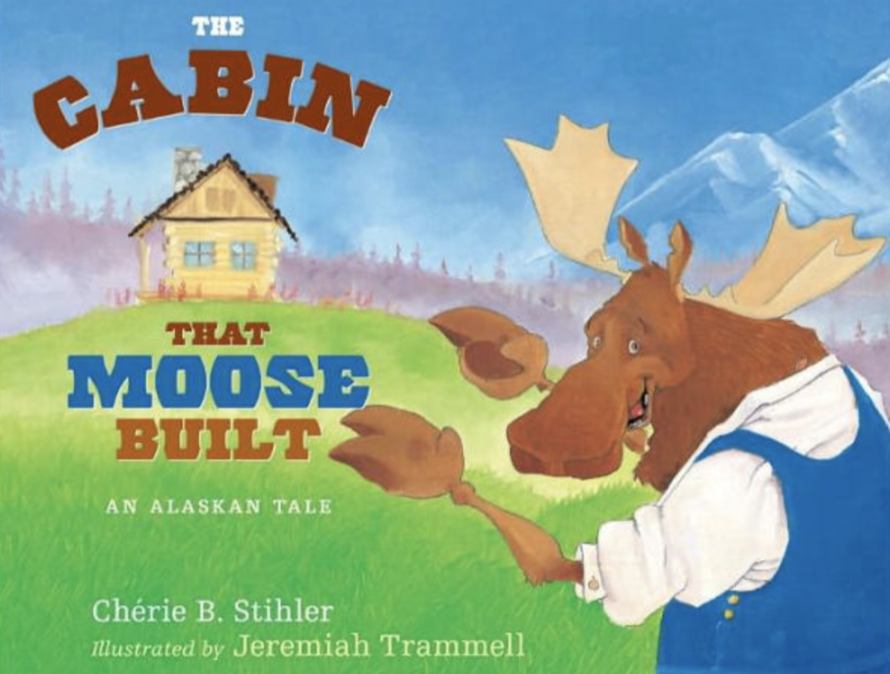

Build An Alaskan Cabin
Participants will explore many factors (windows, construction materials, insulation, doors, heat source, passive solar, topography, orientation) when considering climate and energy efficiency as they build an Alaskan cabin. This is a hands-on engineering activity session, mixing in Maker Education and utilizing exciting but accessible materials (conductive tape, LED lights, coin cells). This session will provide teachers the supplies to implement this relevant lesson with students in your Silhouette digital cutter, evaluate prototype for accuracy, make changes as needed, and design final model for laser cutting out of wood.

Materials:
Cardstock, Silhouette cutter, conductive tape, LED lights, Coin Cells, 1/8 in plywood and laser cutter.

Students will also complete a written description of energy efficiency considerations
and climate impacts such as flooding and extreme storms with their model.

Standards:
NSGG Connections to Technology, Engineering, and Applications of Science Dimension.

