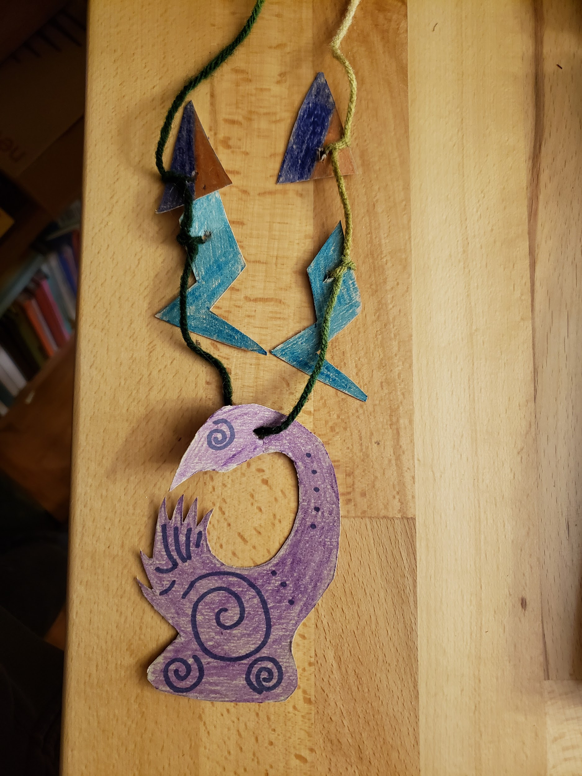
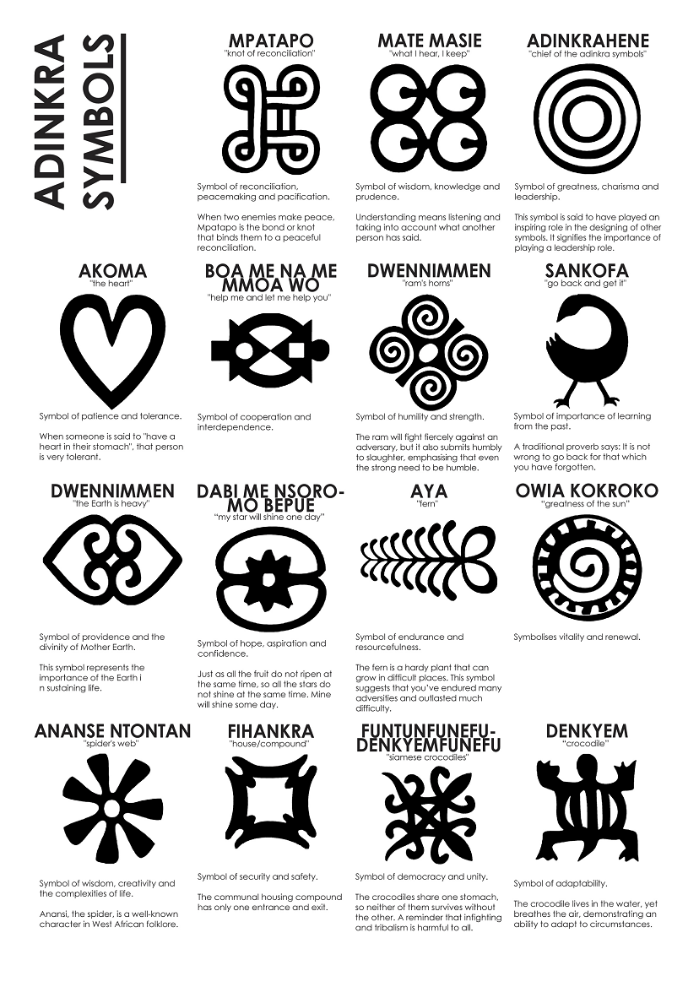
Pride Pieces: Exploring Social Identity, History, and Culture
A culturally situated lesson using Adinkra Symbols and Marvel’s The Black Panther
Adrinkra Symbols and African Art
Adinkra Symbols- Wikipedia
Black Panther Costuming
Marvel’s Comic Book References
Marvel’s Character spotlight, article, videos
Movie Official Trailer
Social Identity Wheel Adaptation/ LSA’s social identity wheel
Based on a lesson created by: Ainsley Buckner, Melvin La Prade, and Sonya Prior-Jones, and adapted by Katy Perry
Subject Areas: Social Studies, ELA, Arts, and Culture
K-5, 6-8, 9-12

Students will create a neck piece based on symmetry, patterns, and colors seen in Black Panther as well as in traditional African Adinkra art. They will learn how to simulate cultural and visual information to create their own symbolic neck piece.
Students complete a Social Identity Wheel to help them reflect and discuss their cultural identity.
Students will be more aware of how visual symbols, color, and patterns are used in past and present social cultures and how they influence our personal identities. Students will develop skills and confidence with their ability to express themselves as creative problem solvers and makers.

Key Vocabulary
- Adinkra – visual symbols that represent concepts or aphorisms. Adinkra are used extensively in fabrics and pottery among the Ashantis of Ashanti Kingdom and Baoulés of Cote d’Ivoire. They are incorporated into walls and other architectural features.
- Symmetry- the work of art is the same on one side as the other, a mirror image of itself, on both sides of a center line
- Cultural Identity- Cultural identity is the identity of belonging to a group. It is part of a person's self-conception and self-perception and is related to nationality, ethnicity, religion, social class, generation, locality or any kind of social group that has its own distinct culture.
- Embossing – to carve or stamp a design on a surface so that it stands out in relief.
- Additive Manufacturing – the process of joining materials to make objects from 3D model data, usually layer upon layer. An example of this is 3D printing.
- 3D Modeling – is the process of developing a mathematical representation of any surface of an object (either inanimate or living) in three dimensions.
Materials List
- Paper – for templates
- Pencils, markers, crayons (or what is available)
- Cardboard, box board (cereal box material), posterboard or heavy cardstock- for amulets and neck piece pattern beads.
- Scissors
- Ruler or straight edge
- String, yarn or lanyard (for the necklace)
- Optional: glue, paints, embellishments
Digital Fabrication Equipment
- Computer with internet connection
- Optional: Google Drawings or other graphic design software; Vinyl cutter/paper cutter, vinyl or paperboard
- Optional: TinkerCAD,v3D Printer and filament

Lesson Objectives
Essential Questions
- What can visual symbols, color, and pattern tell us about a culture or society?
- What influences creative expression and identity? How do the arts shape, as well as reflect, a culture?
- How can you use symbols to display your identity? How can you create an amulet to show these symbols?
- What do effective problem solvers do when they get stuck?
Strategies for Student Engagement and Voice
The students will explore and discuss the black and African cultural aspects and symbols portrayed in the Black Panther movie. Students will complete their Identity Wheels and, in small groups, students will share personal cultural symbols.
The students will have voice and choice in choosing the shape of their amulet, the color of their beads, the selection of charms, and the pattern of their assembled neck piece. Their decisions will be based on which cultural symbols and colors they want their neck piece to represent.

Lesson Introduction
This introduction exercise has 3 main components; an opening discussion with guiding questions (following viewing the costuming clip, and previews, comics, movie, or books about Black Panther), completion of the social identity exercise, and a closing discussion correlating the introduction activity with the purpose for making their artifact (Pride Piece) using multimedia and artifacts.

Some potential guiding questions for the teacher -led opening discussion:
- What do we know about the movie Black Panther? The comic books? Movie soundtrack?
- What are some major themes about the film/story?
- What are social identities? How are they formed?
- What symbols represent cultures in Black Panther?
Each student will complete a Social Identity Wheel worksheet to facilitate discussion and reflection focus. Social Identity Wheel
Social Identity Wheel Name:

Family Income
Religion
Race
Ethnicity
Age
Languages
Nationality
Sexual Orientation
Gender
Ability
Personal
Motto
Favorite
Music
Siblings
and Family
Skill you are
Proud of
Family
Traditions

- Family Cultural Identities that have the strongest effect on how you see yourself:

- Family Cultural Identities that have the greatest effect on how others see you:

- Students will complete as many of the boxes as they can to describe their social identity and share 2 or 3 category responses with the class.
Have additional discussion about social identity:
- Where do we think social identities come from? What social identities were represented in the film? Which social identities did you relate to?
- As a group, watch Ruth Carter, the costume designer talk about how social identities were represented in the movie. See clip here: https://www.youtube.com/watch?v=mmP1aHJjJ-U
- Highlight the big themes and discuss some of the vocabulary and interesting facts that Ruth shares her scene notes clip. This includes the Adinkra symbol on Suri’s shirt, the role of makeup and tattooing the colors and materials used in the film like red, black, green, purple, gold/
- If possible :Reference any tangible artifacts that you have brought into the space. This may include African art, cloth, currency, or jewelry.
Students will make an artifact of their own that reflects social identity. Discuss T’chala’s pendant from the movie. Students could explain what they think was his superhero crest and why?
Tell students: You will follow an algorithm but also use your own interest, and social identity to create something that represents you, and your history and culture. When you complete your Pride Piece, think about, what new social identities can we construct for the future in a place like Wakanda? Then add it to your social identity wheel.

Amulet Neckpiece
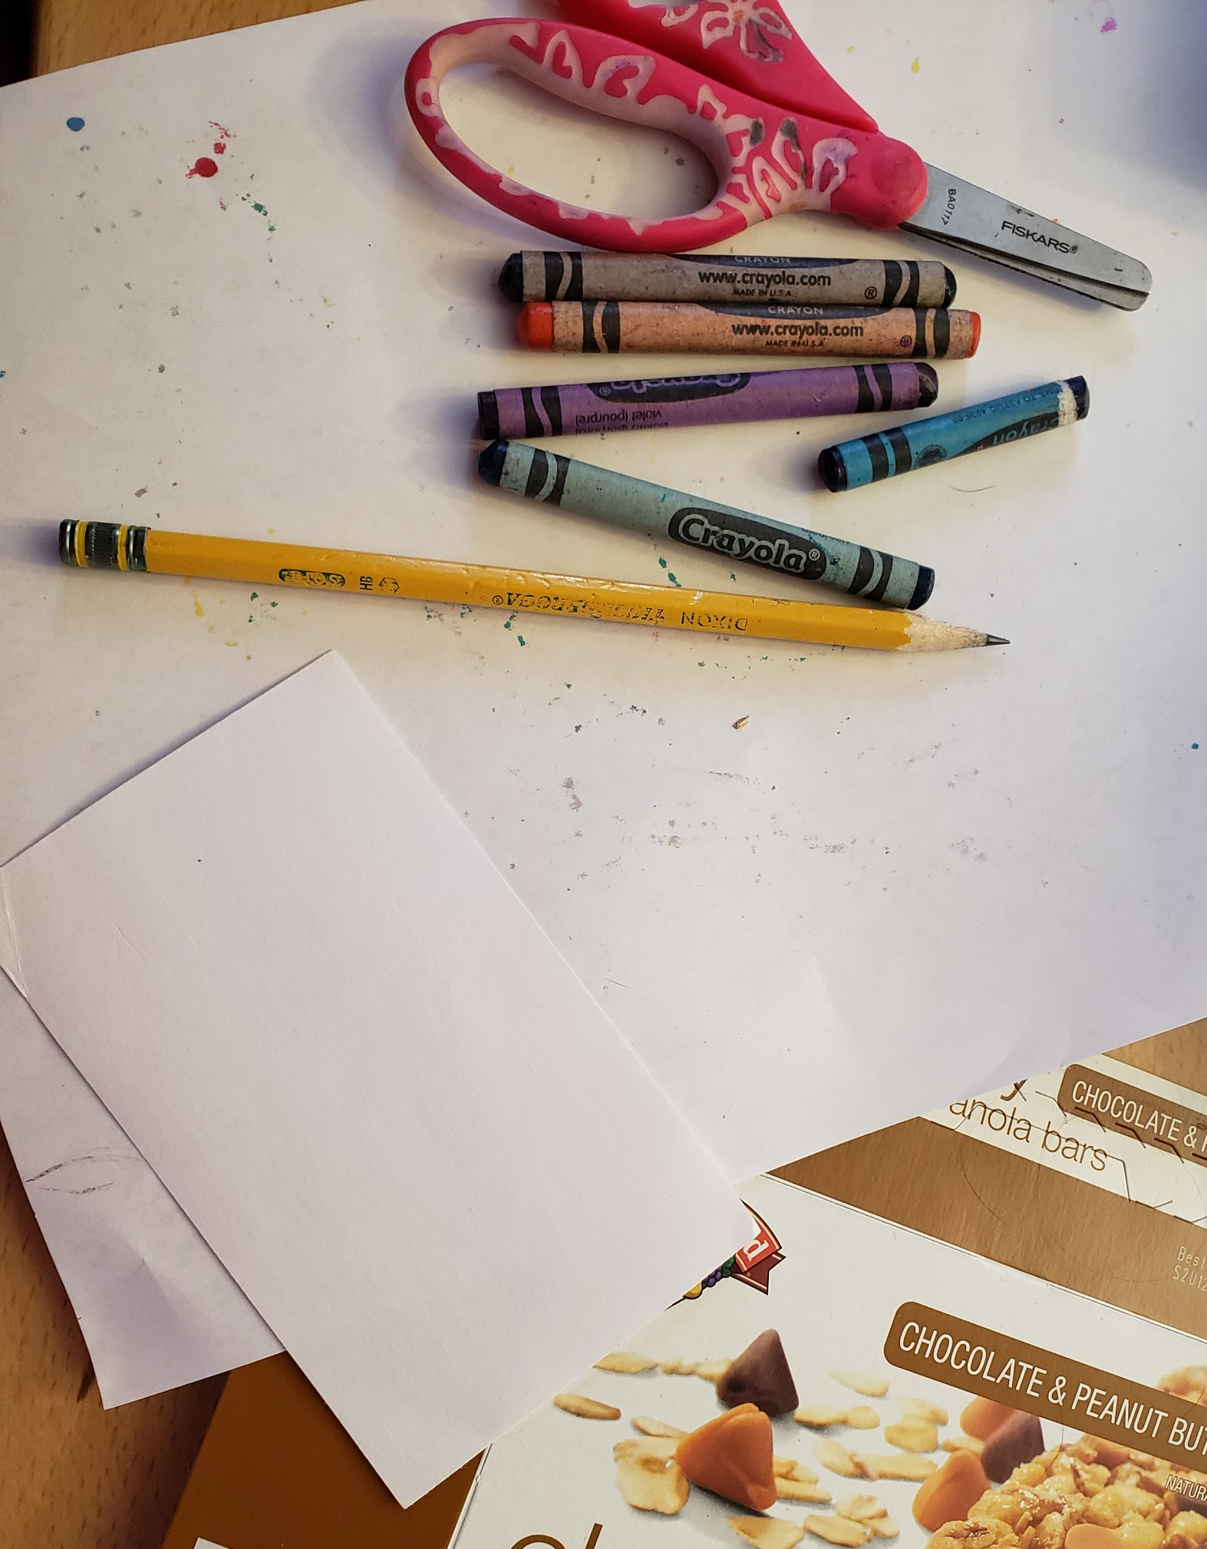
Student generated designs representing culture and identity. Depending on tools and materials available, amulets and smaller beads will be made from poster board, box board, cardboard, or other accessible stiff paper.

Supplies (per student):
Template Paper
Marker, Pencil, Pen
Scissors
Poster Board, Box Board, Cardboard, Stiff paper plates...
Items to decorate cut out amulet and smaller bead (markers, crayons, foil etc)
Cord or string 24”

Show students completed amulet examples.
- Give demonstrations on designing/drawing amulets on paper templates. If a vinyl cutter or laser cutter is available, have students use Google Drawings and download jpegs to cut.
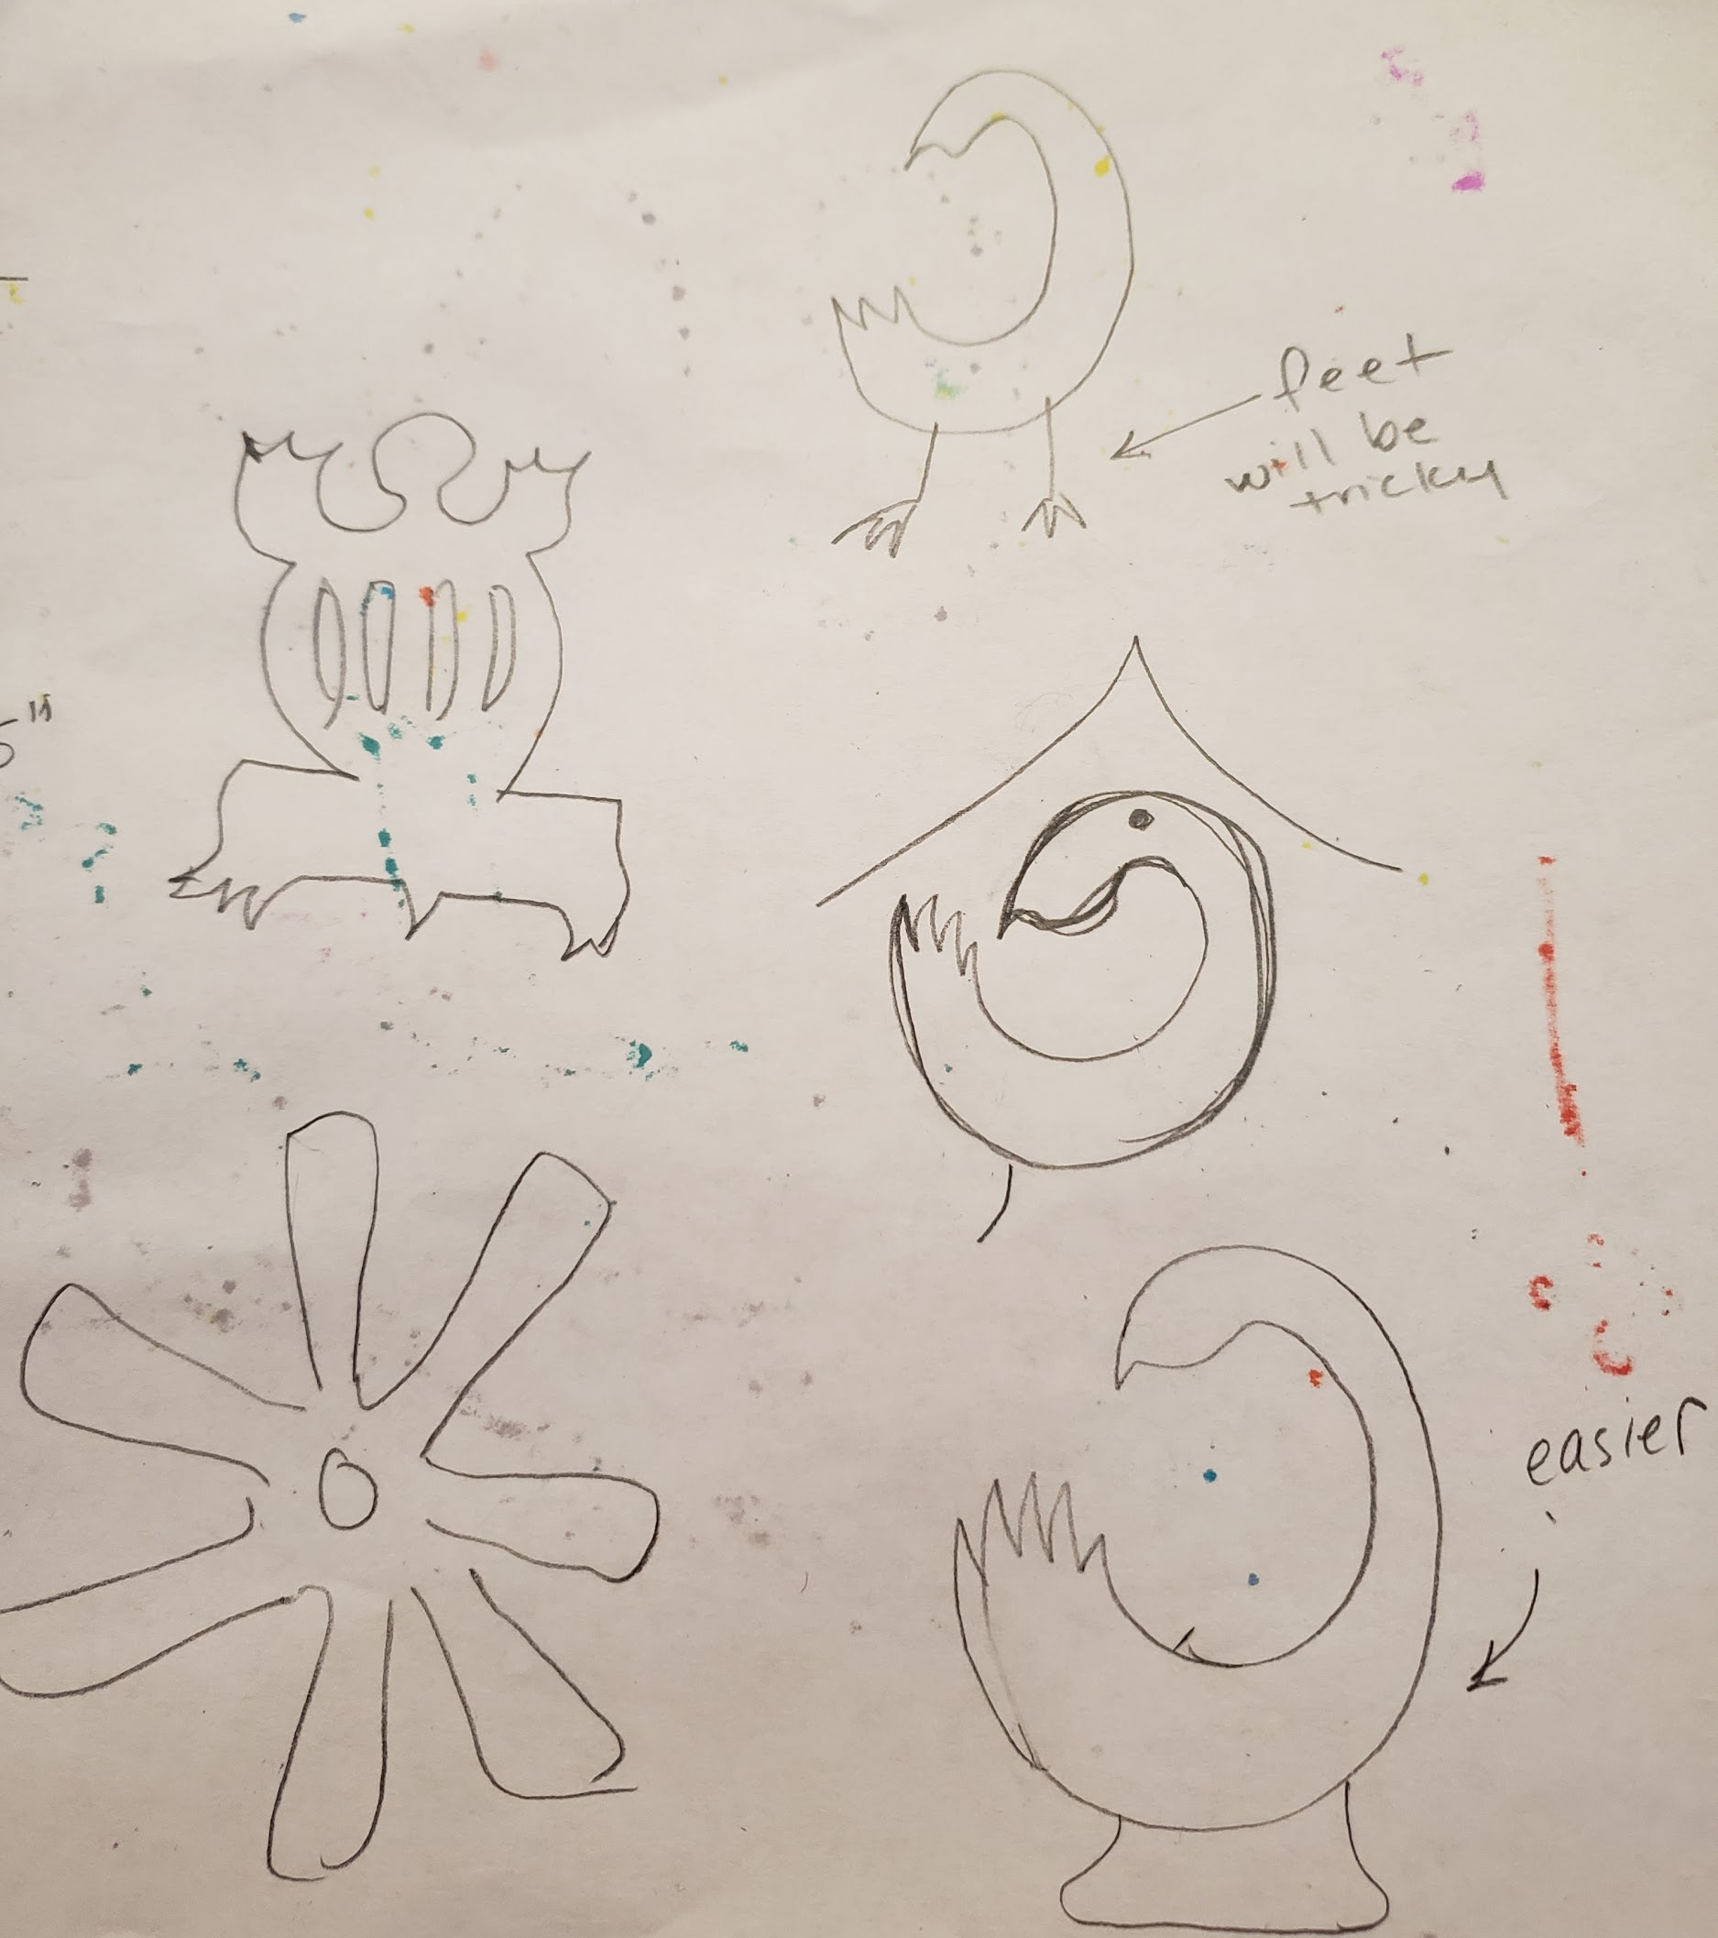
Lead a brainstorming session with students: Which symbols and shapes can you use for your amulet? Why? What visual metaphors can be drawn from the symbol you chose to be your amulet? Are there any cultural references portrayed by your symbol?

Students will sketch ideas for their amulet. Optional small group discussion and feedback on designs.
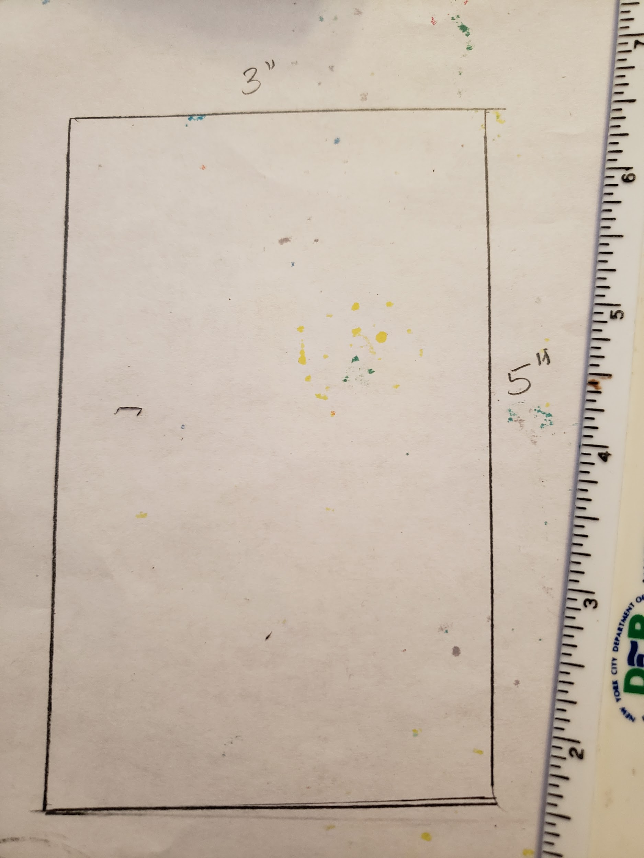
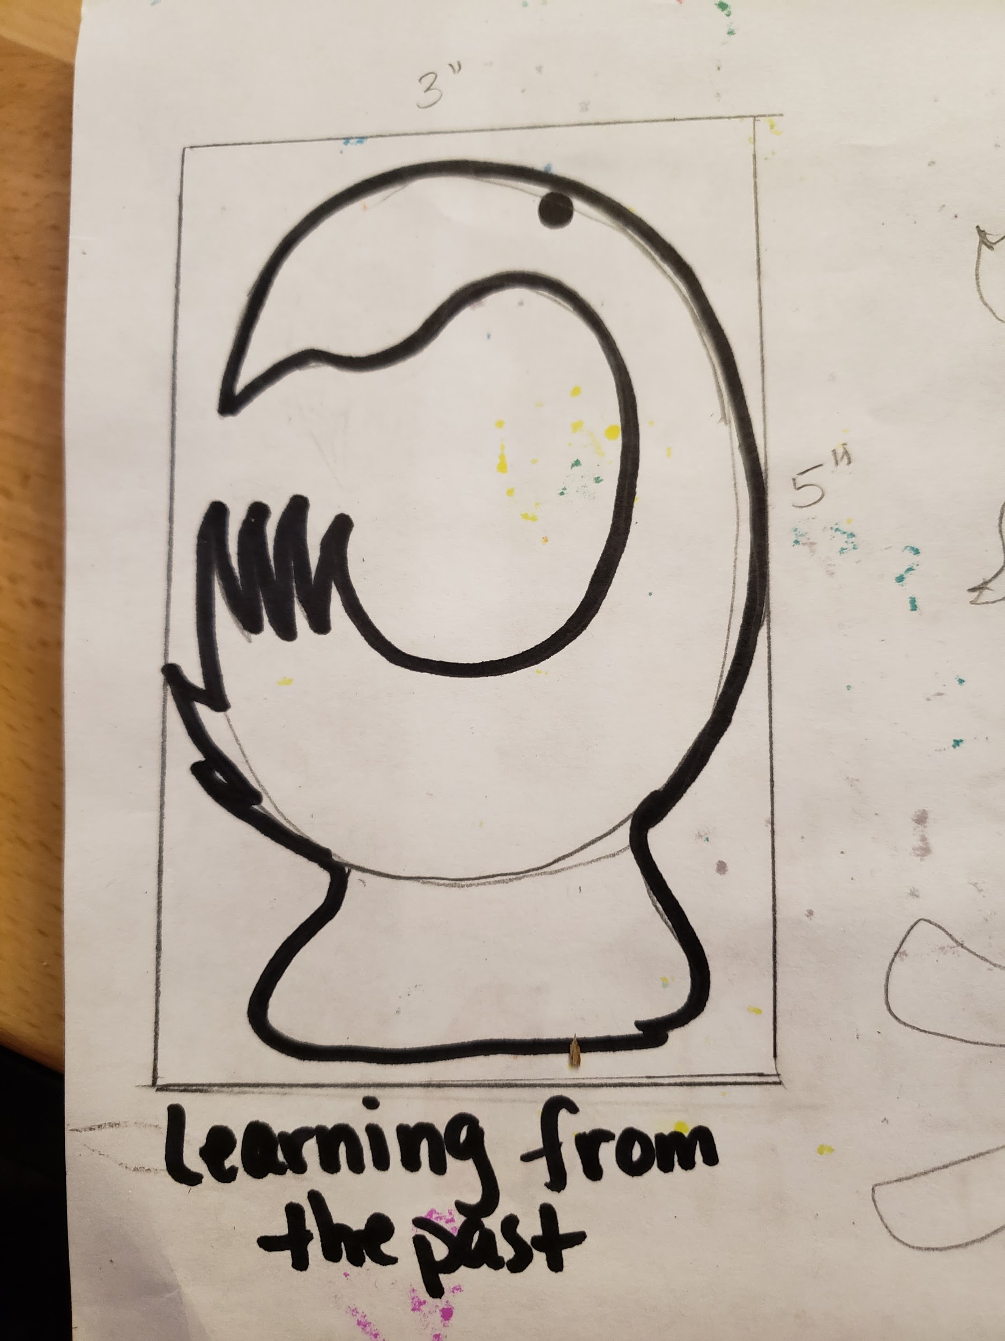
Students must draw outlines, no shading or filling in shapes. All shapes must be closed shapes and include a pencil sized hole for running the cording through.

Students will draw 2 (or more) 3” x 5” rectangles as templates. Students will draw their amulet designs on the template.
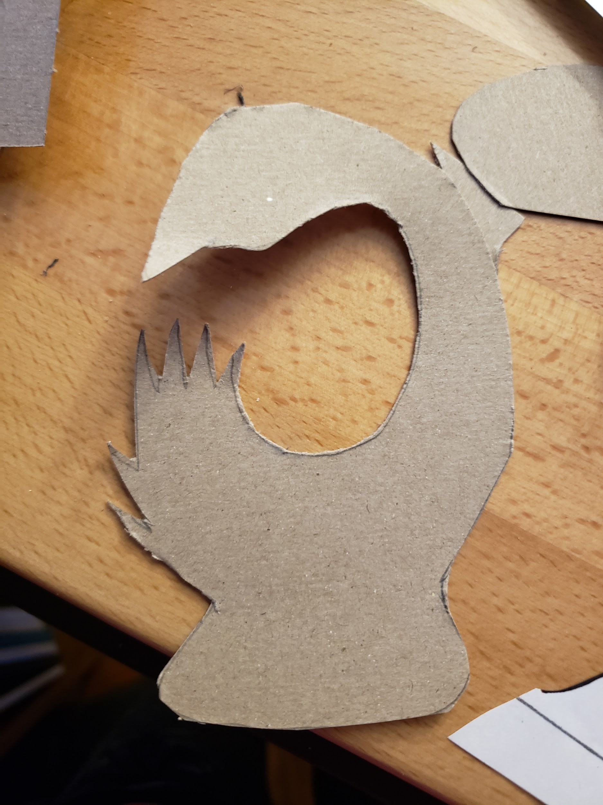
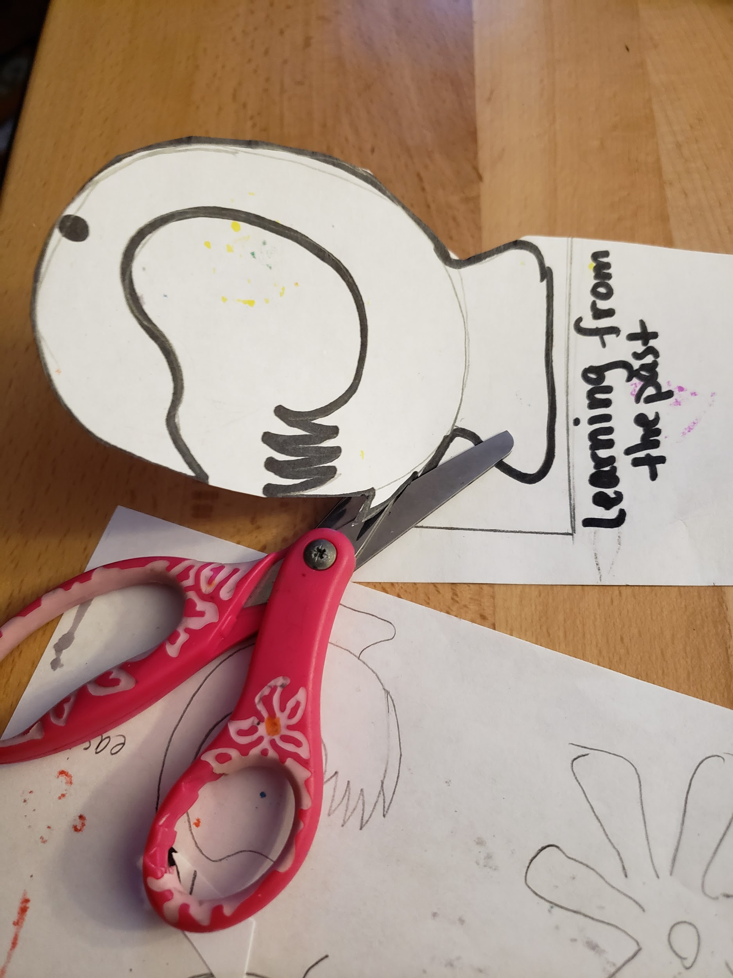
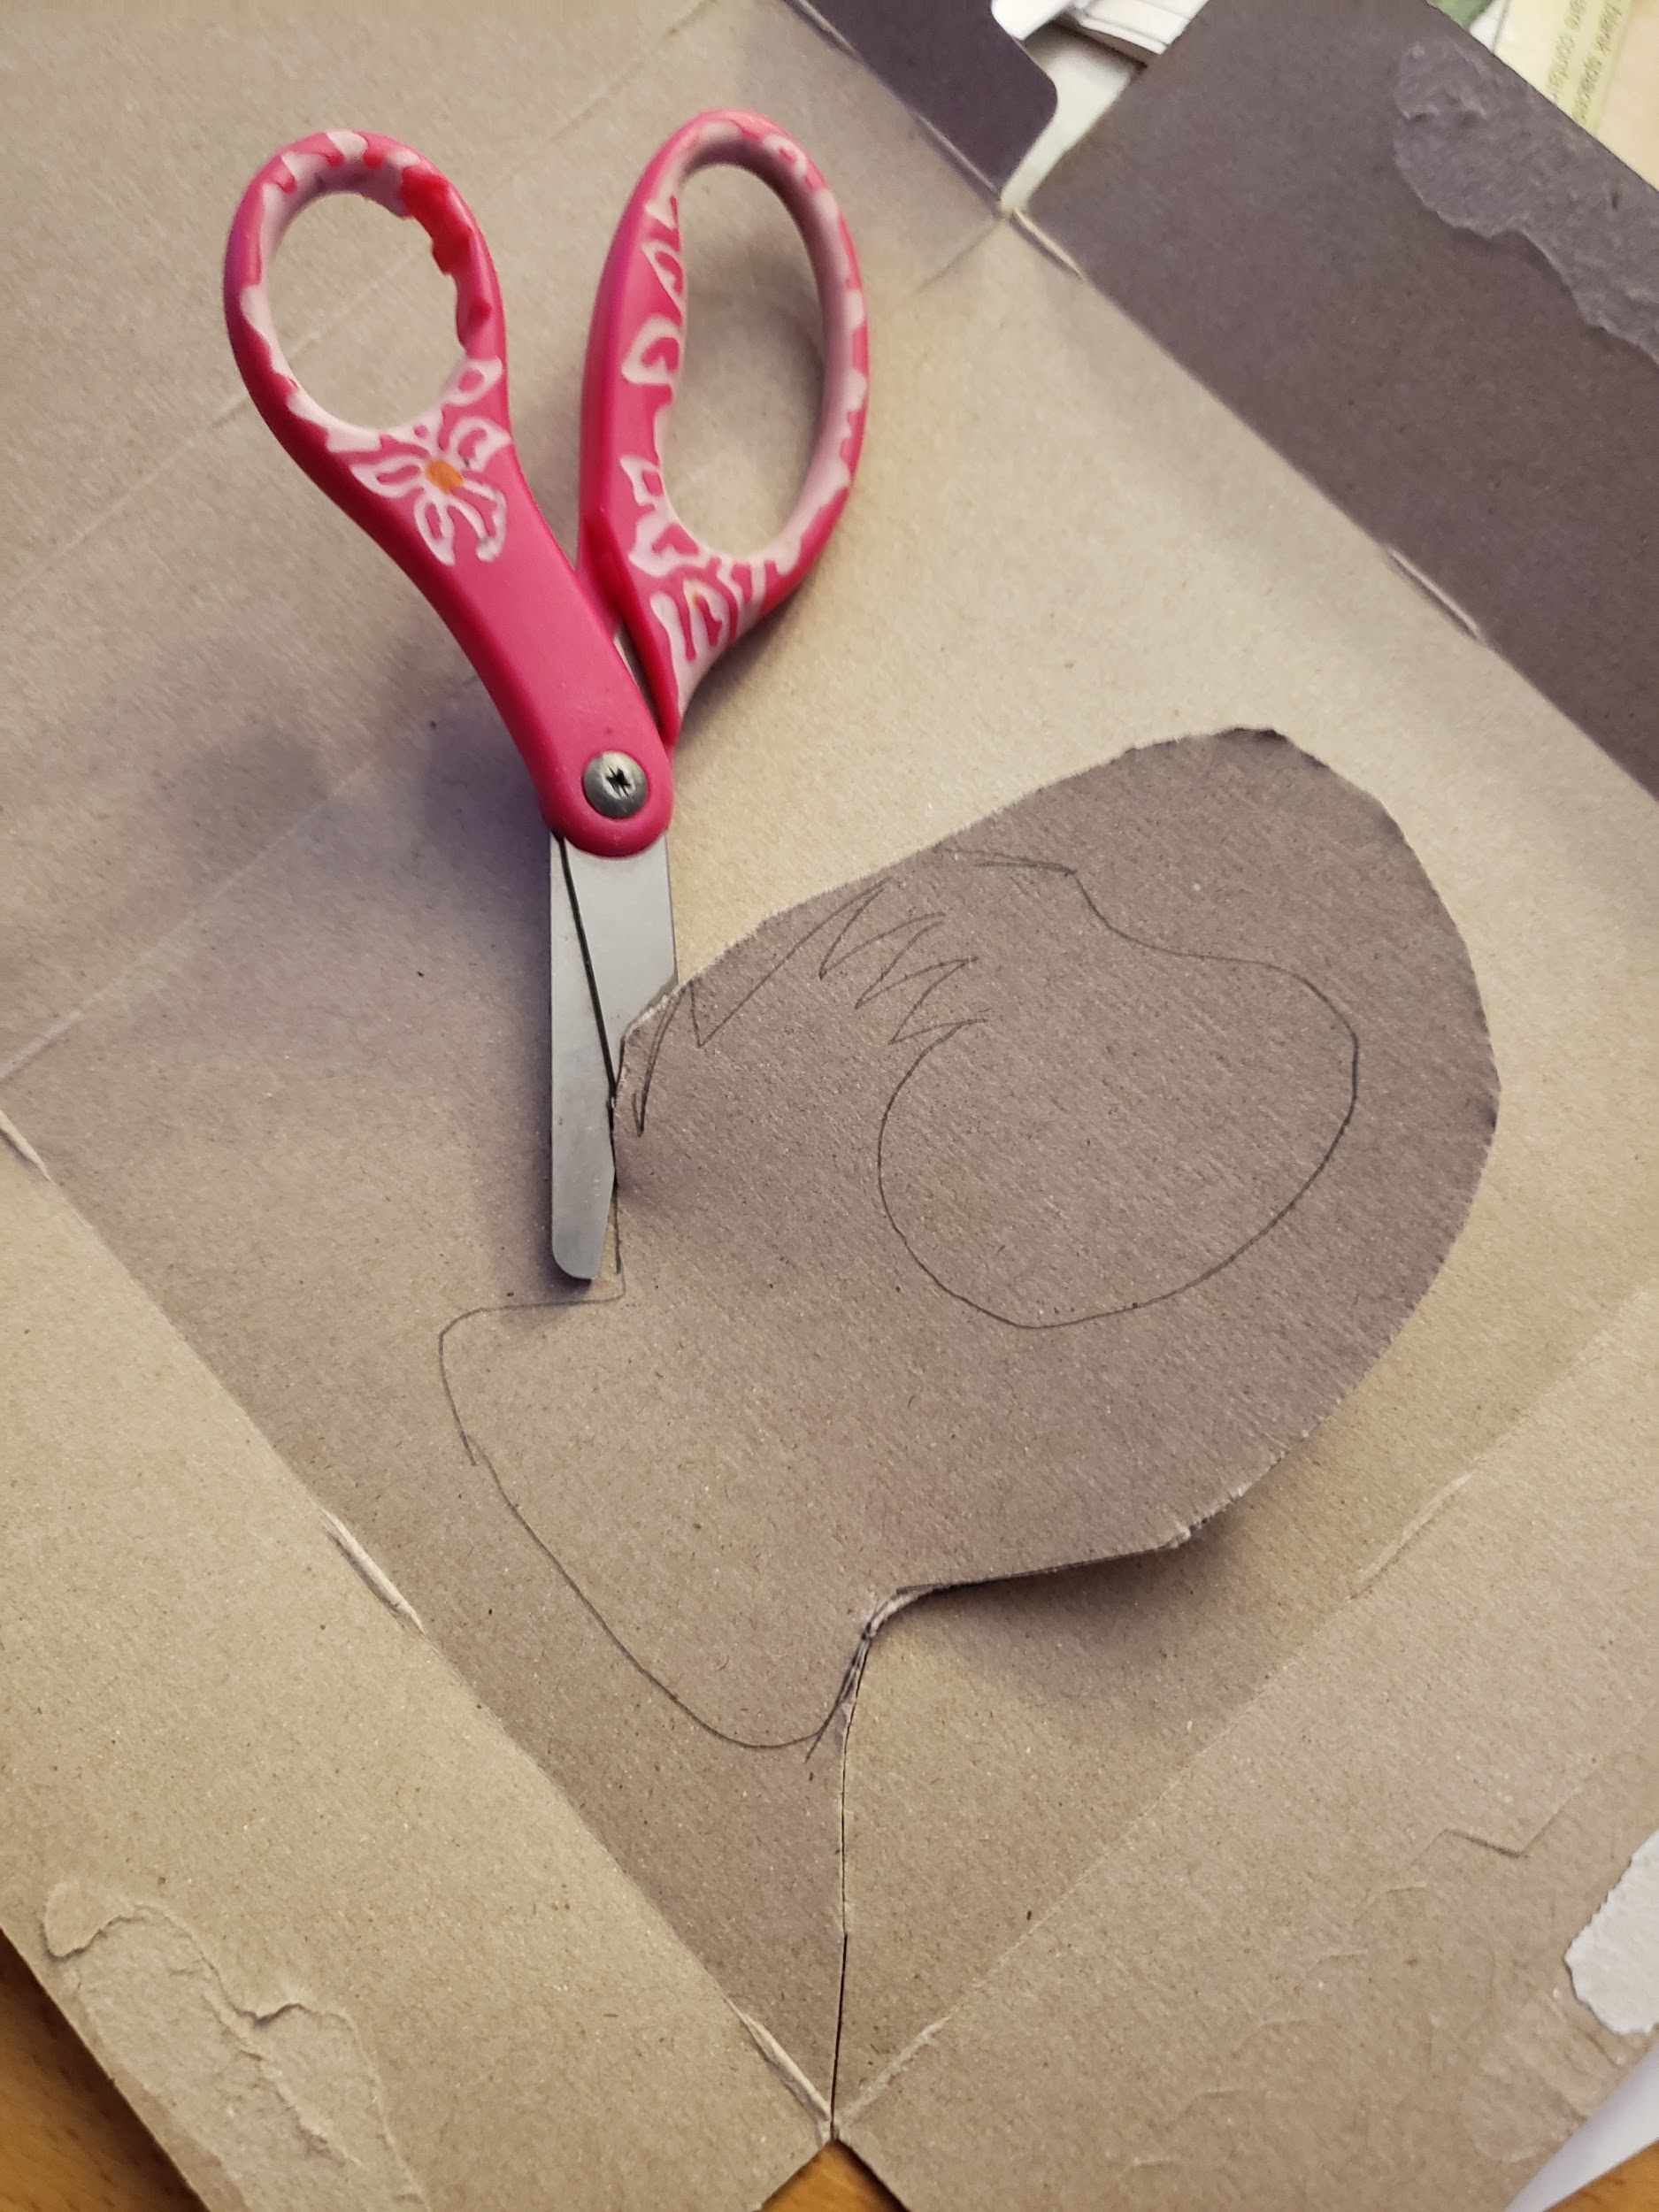
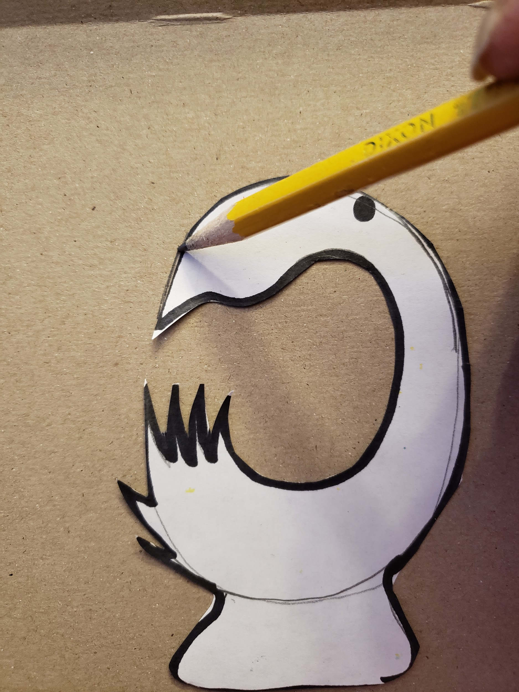
- They may draw several shapes and choose one design they would like to create.
- Students will cut out the template and use it to trace the amulet design onto paperboard. Students will then cut out the traced pattern. Decorate and thread to the center of the cord.
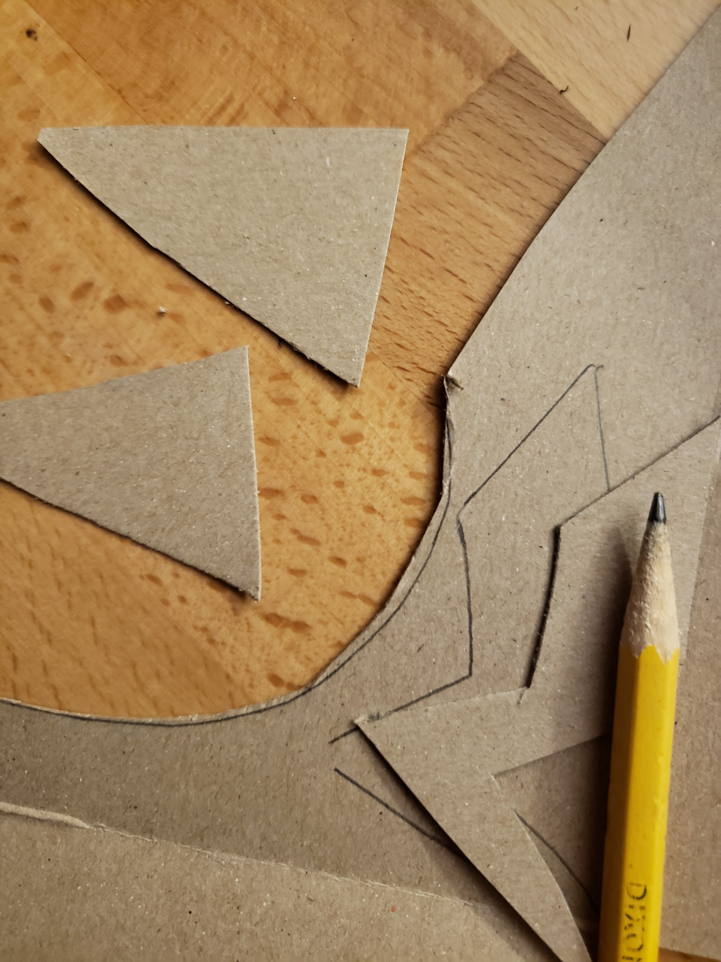
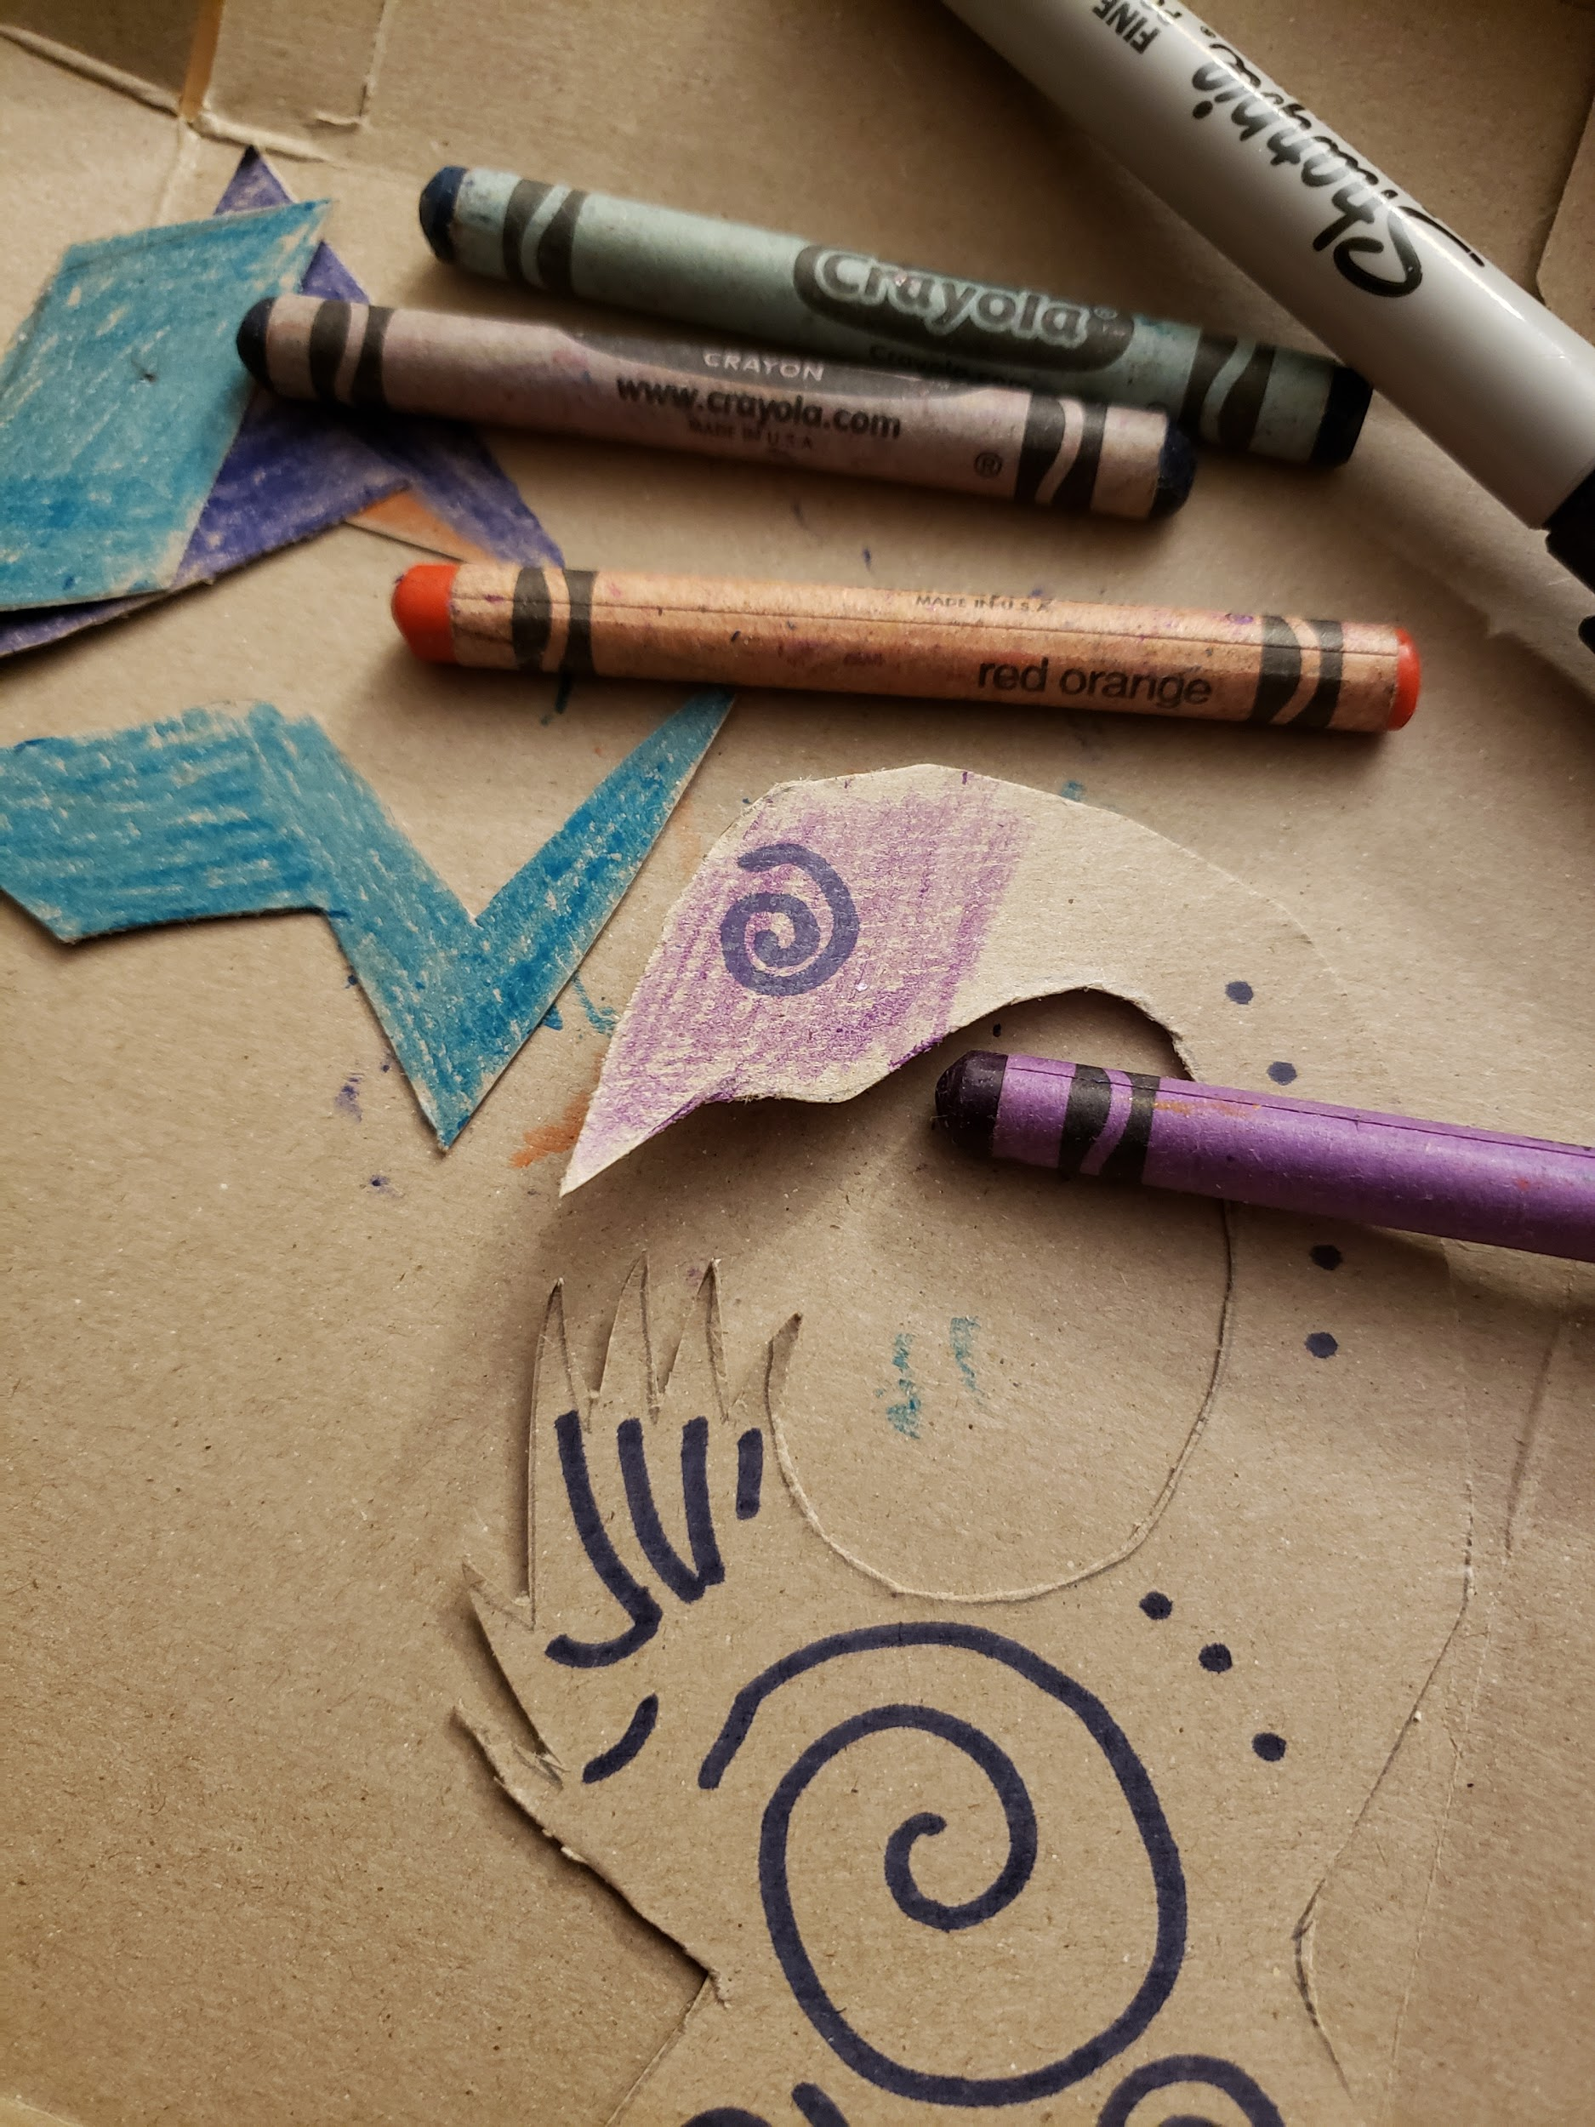
- Students can design beads from paperboard, color, and thread in a symmetrical pattern on either side of the amulet.

Reflection Questions:
What was the intent behind the pattern you assembled?
Does the overall design of your neck piece represent your original idea?

Plan for Student Reflection
Students will share the symbolism behind their neck pieces after construction.
- Why did you choose the symbols you did for your amulet and charms? What do they represent for you?
- How do Adinkra Symbols express ideas?
- How are symbols used in Black Panther as identities?
- How do cultures use symbols to express connections?
- Why are cultural symbols important?
- What is something new you learned about African cultures?
- What is something you would like to learn more about?
Potential Questions for Post Qualitative Assessment
- How else does culture use symbols?
- Does symbolism used in advertisement and media affect your opinion of the product being presented?
- Advertising is a form of communication intended to convey a message, what message are you conveying in how you represent yourself to society?

Option: 3D Printed Beads:
Preparation:
Make TinkerCAD accounts for students
3D print at minimum 4 beads per student (choose filament colors that will be discussed).

Station Objective:
Introduce students to 3D modeling software and additive manufacturing process.
Brief Description of Activities:
- Teacher shows students the example cylinder bead.
- Introduce TinkerCAD and have each student login in.
- Take students through the steps listed in (BlackPantherBead-TinkerCADTutorial) to create their cylinder bead.
- During tutorial ask students:
- What is 3D Modeling? (Talk about x, y, and z axis while showing students them in TinkerCAD program. Explain how parameters are required to determine the position of an element (i.e., point). This is the informal meaning of the term dimension.)
- Explain what diameter means
- How do we know what size to make the diameter? (Introduce the word tolerance and talk about how the hole has to be big enough to fit the string.)
- Teacher demonstrates how to import and setup stl file into 3D printing software.
- Scale
- Orientation
- Resolution (layer height)
- Speed
- Teacher demonstrates how to set up 3D printer.
- Select material
- Check bed surface/leveling
- Load filament
- Teacher starts demo print.
- Explain to students that there will not be time for them to print each of their own beads and that we have pre printed beads in the colors discussed earlier in the symbolism discussion that they can pick from.
Reflection Ideas:
How does scale and proportion influence the design of the product?
Supplies:
3D printer and Filament, computers with internet access
Activity Files:
BlackPantherBead-TinkerCADTutorial

