Steig, W. (1988). Brave Irene. New York, N.Y.: Farrar, Straus & Giroux.
The story centers on Irene’s arduous journey through a snowstorm to deliver a dress her mother had made to the Duchess. Irene’s perseverance through adversity sends an important message to readers. Also available in Spanish: Steig, W., & Mlawer, T. (1991). Irene, la valiente. New York: Farrar, Straus and Giroux.
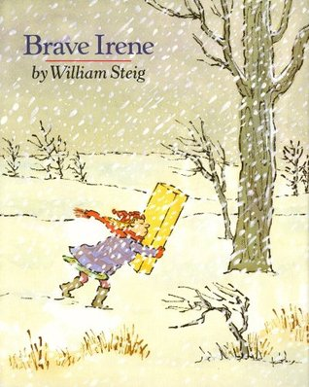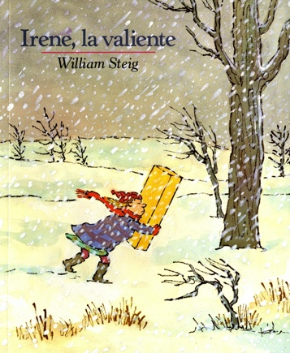
Top of Form
Bottom of Form

Pett, M., & Rubinstein, G. (2011). The girl who never made mistakes. Naperville, IL: Sourcebooks Jabberwocky.
This book tells the story of a girl who had never made a mistake making her first mistake in front of a large audience! This book sends the message that it is okay to make mistakes.
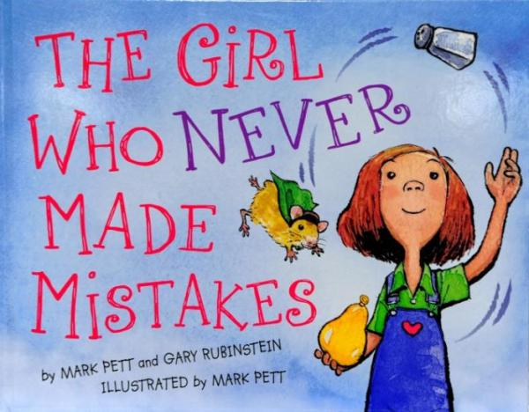

Reynolds, P. H. (2004). Ish. New York, N.Y.: Simon & Schuster.
In this book, Ramon is able to adapt an “ishful” outlook that enables him to appreciate his poems and drawings for what they are rather than trying to achieve some standard of perfection or correctness.
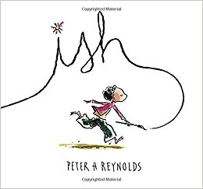

Top of Form
Beaty, A., & Roberts, D. (2017). Rosie Revere, engineer. New York, N.Y.: Abrams Books for young readers.
The story of Rosie’s attempt to create a new contraption failing not stopping her from getting up and trying again teaches the value of persistence.
Bottom of Form
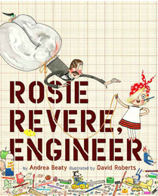

Judge, L. (2014). Flight school. New York, N.Y.: Atheneum Books for Young Readers.
This story of a penguin that wants to fly and ultimately succeeds thanks to his friends’ assistance teaches students not to give up on their goals but rather to let others support them in getting there.

Williams, V. B., & Greenwillow Books. (1982). A chair for my mother. New York, N.Y.: Greenwillow Books.
T book shares similar values to Brave Irene, such as facing adversity with perseverance and helping those we care about.

Park, L. S., Malcolm, G., & Ingram Digital (Firm). (2011). A single shard. New York, N.Y.: Listening Library.
This longer chapter book shares many themes with Brave Irene. Some such commonalities are the arduous journey to bring a delicately crafted work to the royalty and the main character’s perseverance even through very trying situations. Although the book is at a higher reading level and may be too difficult for some students, it would be an appropriate challenge for some higher-level readers, and it might also work as a long-term read aloud (a few pages a day, perhaps during snack).
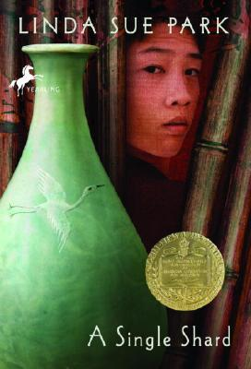

Manes, S. (2006). Be a perfect person in just three days!. Vancouver: PRCVI.
This book exemplifies that being perfect is extremely difficult, and frankly quite boring- staining your shirt with ketchup is much more fun! Again, this book reinforces that it’s okay to make mistakes.
